Lab - Week 4

PART A
(PART A: TO BE REFERRED BY STUDENTS)

Objective Build a to-do app with React Hooks.

Theory:

React Hooks like useState and useEffect provide functional components with the ability to manage state and handle side effects, respectively. In this lab, we will explore their practical application in creating a dynamic and interactive To-Do application.
Key Concepts:

- useState: For managing the state of tasks in the To-Do app.
- useEffect: For logging actions or performing side effects based on state changes.
- State Management: Adding, deleting, and marking tasks as completed.
- Dynamic Rendering: Updating the UI in response to user actions.

PART B
(PART B: TO BE COMPLETED BY STUDENTS)
Students must submit the soft copy as per following segments within two hours of the practical. The soft copy must be uploaded on the portal at the end of the practical. The filename should be AWT_batch_rollno_experimentno Example: AWT_A1_A001_P1

Roll No.: A006 | Name: Aksh Soni
Prog/Yr/Sem: MCA – Sem2 | Batch: 01
Date of Experiment: 10-02-2026 | Date of Submission: 10-02-2026

Task 1: Build the To-Do App

- Setup React Environment:
  - Create a new React project using create-react-app.
  - Install any necessary dependencies for UI styling (optional).

Create Task Management Features:
  - Add Tasks: Implement a form with an input field and a button to add new tasks to the list.
  - Delete Tasks: Add a delete button next to each task to remove it from the list.

  - Mark Tasks as Completed: Allow users to mark tasks as completed using a checkbox or button.

State Management:
  - Use useState to maintain the list of tasks, where each task is an object containing:
    - id: A unique identifier for the task.
    - text: The task description.
    - completed: A boolean indicating whether the task is completed.

Side Effects Logging:
  - Use useEffect to log actions to the console (e.g., "Task Added", "Task Deleted").

UI and Styling:
  - Display tasks in a list format.
CODE:-
import { useState, useEffect } from "react";
import "./App.css";

function App() {
const [tasks, setTasks] = useState([]); // Task list
const [text, setText] = useState(""); // Input text
const [nextId, setNextId] = useState(1); // Unique ID

// Log task actions
useEffect(() => {
console.log("Task list updated:", tasks);
}, [tasks]);

// Add task
const addTask = () => {
if (text.trim() === "") return;

setTasks([
...tasks,
{ id: nextId, text: text, completed: false }
]);

console.log("Task Added");
setNextId(nextId + 1);
setText("");
};

// Toggle completed
const toggleTask = (id) => {
setTasks(
tasks.map((task) =>
task.id === id
? { ...task, completed: !task.completed }
: task
)
);
};

// Delete task
const deleteTask = (id) => {
setTasks(tasks.filter((task) => task.id !== id));
console.log("Task Deleted");
};

return (
<div className="app">
<h1>To-Do List</h1>

<input
type="text"
placeholder="Enter a task"
value={text}
onChange={(e) => setText(e.target.value)}
/>

<button onClick={addTask}>Add Task</button>

<ul>
{tasks.map((task) => (
<li key={task.id}>
<input
type="checkbox"
checked={task.completed}
onChange={() => toggleTask(task.id)}
/>

<span
style={{
textDecoration: task.completed ? "line-through" : "none",
}}
>
{task.text}
</span>

<button onClick={() => deleteTask(task.id)}>Delete</button>
</li>
))}
</ul>
</div>
);
}

export default App;

OUTPUT:-
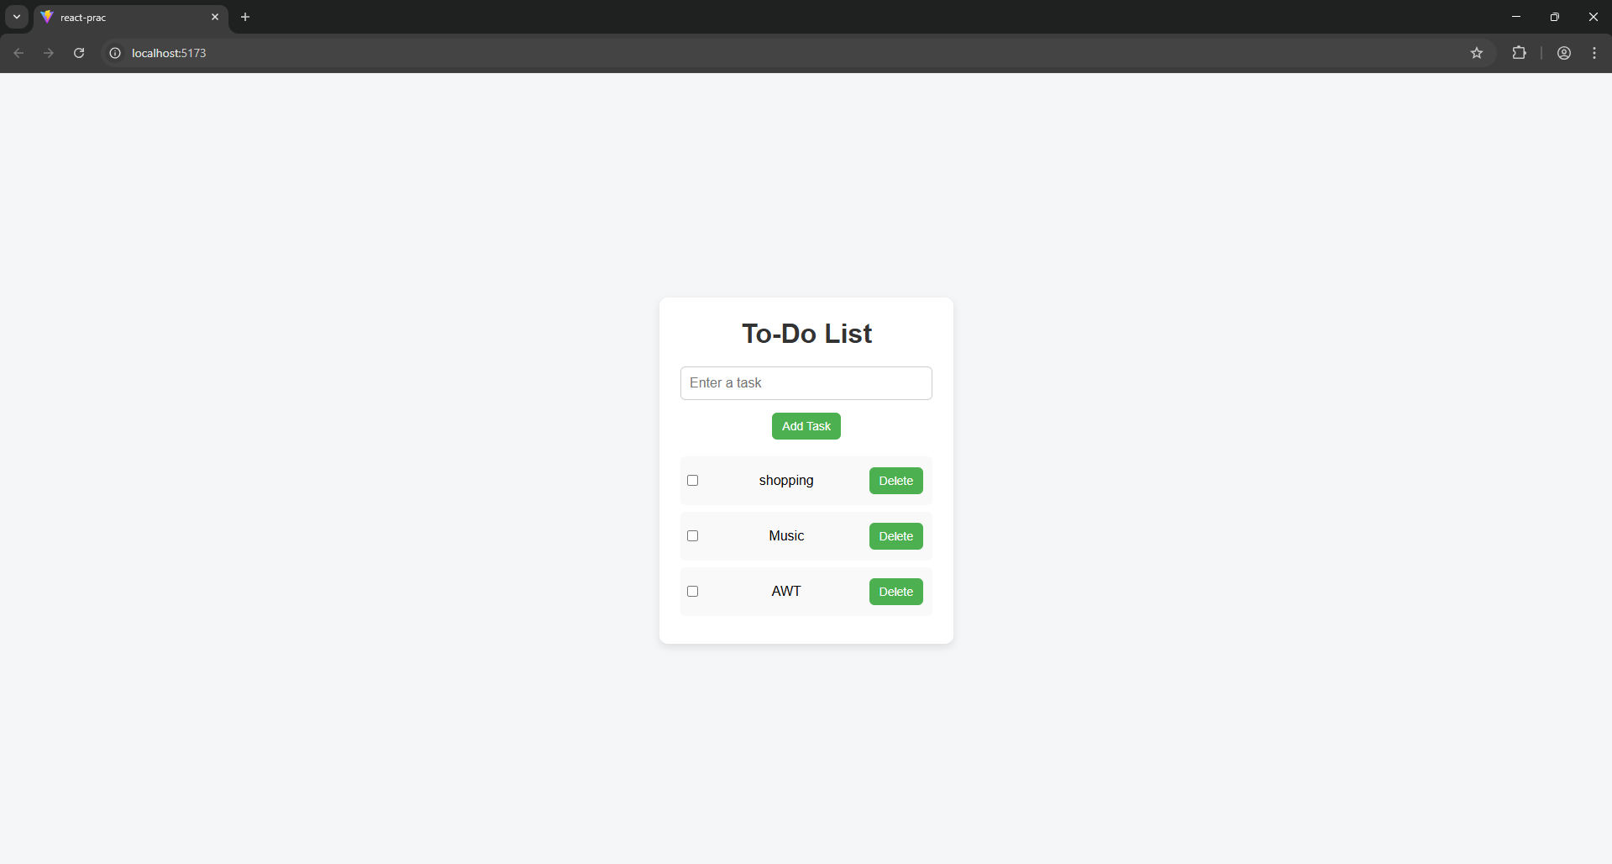
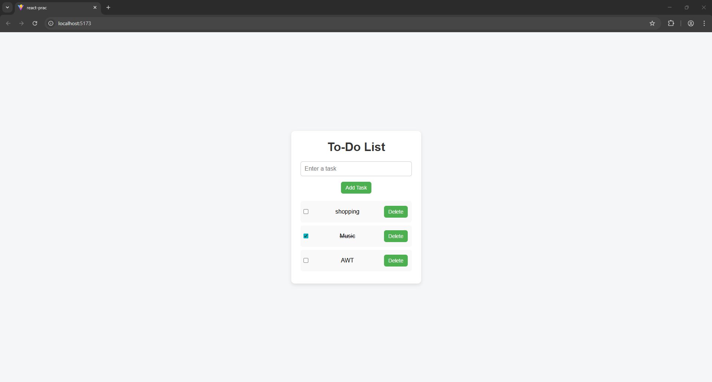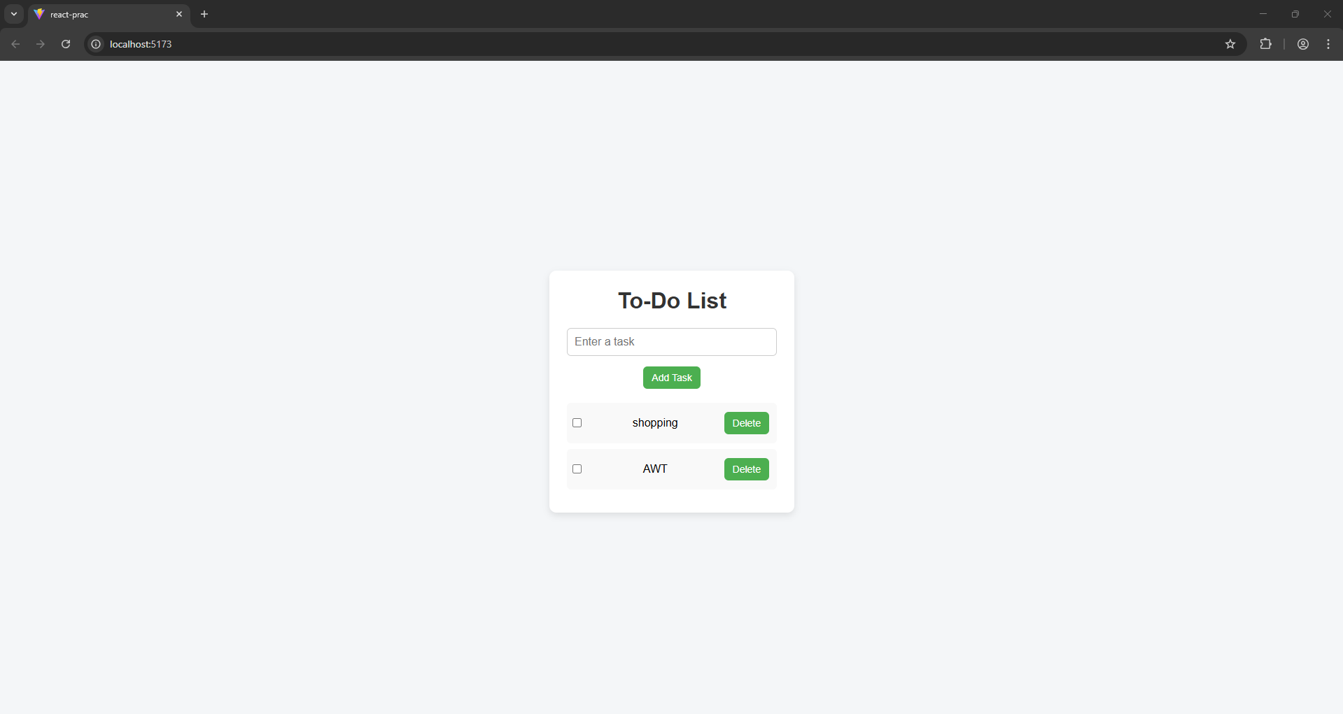

Task 2:

- Budget Tracker:
  - Create a simple budget tracker where users can add income or expenses.
  - Use useState to manage transactions and useEffect to log changes.

Shopping List:
  - Build a shopping list app where users can add items, mark them as purchased, and remove them from the list.

Enhance the To-Do App:
  - Add a filter feature to show All, Completed, or Pending tasks.
CODE:-
App.jsx
import "./App.css";
import TodoApp from "./TodoApp";
import BudgetTracker from "./BudgetTracker";
import ShoppingList from "./ShoppingList";

function App() {
return (
<div className="app">
<h1>Budget, Shopping & To-Do App</h1>

<TodoApp />
<BudgetTracker />
<ShoppingList />
</div>
);
}

export default App;

TodoApp.jsx
import { useState, useEffect } from "react";

function TodoApp() {
const [tasks, setTasks] = useState([]);
const [text, setText] = useState("");
const [nextId, setNextId] = useState(1);
const [filter, setFilter] = useState("All");

useEffect(() => {
console.log("Task list updated:", tasks);
}, [tasks]);

const addTask = () => {
if (text.trim() === "") return;

setTasks([...tasks, { id: nextId, text, completed: false }]);
setNextId(nextId + 1);
setText("");
};

const toggleTask = (id) => {
setTasks(
tasks.map((task) =>
task.id === id ? { ...task, completed: !task.completed } : task
)
);
};

const deleteTask = (id) => {
setTasks(tasks.filter((task) => task.id !== id));
};

const filteredTasks = tasks.filter((task) => {
if (filter === "Completed") return task.completed;
if (filter === "Pending") return !task.completed;
return true;
});

return (
<div>
<h2>To-Do List</h2>

<input
type="text"
placeholder="Enter task"
value={text}
onChange={(e) => setText(e.target.value)}
/>
<button onClick={addTask}>Add</button>

<div>
<button onClick={() => setFilter("All")}>All</button>
<button onClick={() => setFilter("Completed")}>Completed</button>
<button onClick={() => setFilter("Pending")}>Pending</button>
</div>

<ul>
{filteredTasks.map((task) => (
<li key={task.id}>
<input
type="checkbox"
checked={task.completed}
onChange={() => toggleTask(task.id)}
/>
<span
style={{
textDecoration: task.completed ? "line-through" : "none",
}}
>
{task.text}
</span>
<button onClick={() => deleteTask(task.id)}>Delete</button>
</li>
))}
</ul>
</div>
);
}

export default TodoApp;

BudgetTracker.jsx
import { useState, useEffect } from "react";

function BudgetTracker() {
const [transactions, setTransactions] = useState([]);
const [amount, setAmount] = useState("");
const [type, setType] = useState("income");

useEffect(() => {
console.log("Budget updated:", transactions);
}, [transactions]);

const addTransaction = () => {
if (amount === "") return;

setTransactions([
...transactions,
{ id: Date.now(), amount: Number(amount), type },
]);
setAmount("");
};

const balance = transactions.reduce(
(total, t) =>
t.type === "income" ? total + t.amount : total - t.amount,
0
);

return (
<div>
<h2>Budget Tracker</h2>
<h3>Balance: ₹{balance}</h3>

<input
type="number"
placeholder="Amount"
value={amount}
onChange={(e) => setAmount(e.target.value)}
/>

<select onChange={(e) => setType(e.target.value)}>
<option value="income">Income</option>
<option value="expense">Expense</option>
</select>

<button onClick={addTransaction}>Add</button>

<ul>
{transactions.map((t) => (
<li key={t.id}>
{t.type} : ₹{t.amount}
</li>
))}
</ul>
</div>
);
}

export default BudgetTracker;

ShoppingList.jsx
import { useState } from "react";

function ShoppingList() {
const [items, setItems] = useState([]);
const [item, setItem] = useState("");

const addItem = () => {
if (item.trim() === "") return;

setItems([...items, { id: Date.now(), name: item, bought: false }]);
setItem("");
};

const toggleItem = (id) => {
setItems(
items.map((i) =>
i.id === id ? { ...i, bought: !i.bought } : i
)
);
};

const removeItem = (id) => {
setItems(items.filter((i) => i.id !== id));
};

return (
<div>
<h2>Shopping List</h2>

<input
type="text"
placeholder="Add item"
value={item}
onChange={(e) => setItem(e.target.value)}
/>
<button onClick={addItem}>Add</button>

<ul>
{items.map((i) => (
<li key={i.id}>
<input
type="checkbox"
checked={i.bought}
onChange={() => toggleItem(i.id)}
/>
<span
style={{
textDecoration: i.bought ? "line-through" : "none",
}}
>
{i.name}
</span>
<button onClick={() => removeItem(i.id)}>Remove</button>
</li>
))}
</ul>
</div>
);
}

export default ShoppingList;

OUTPUT:-
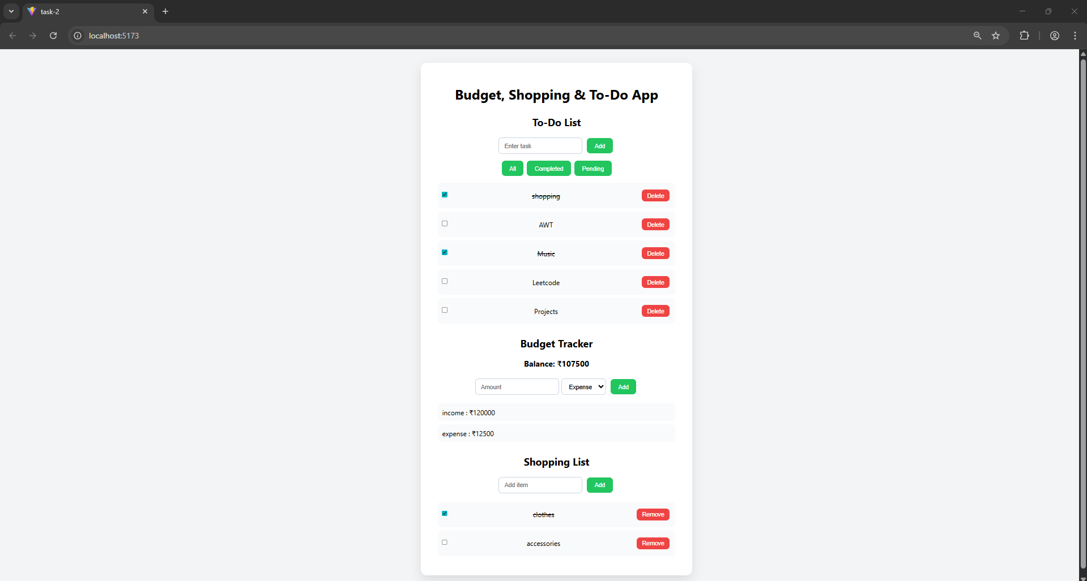
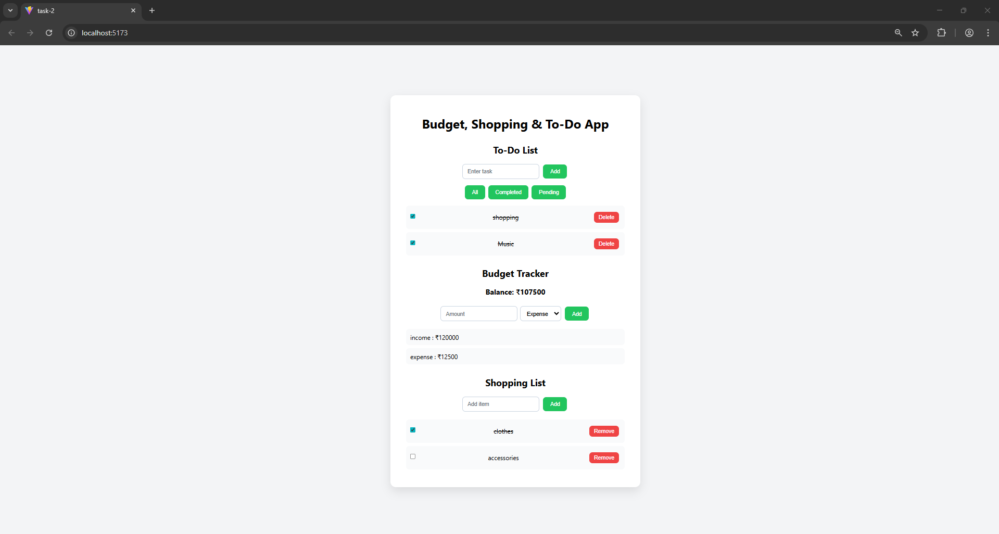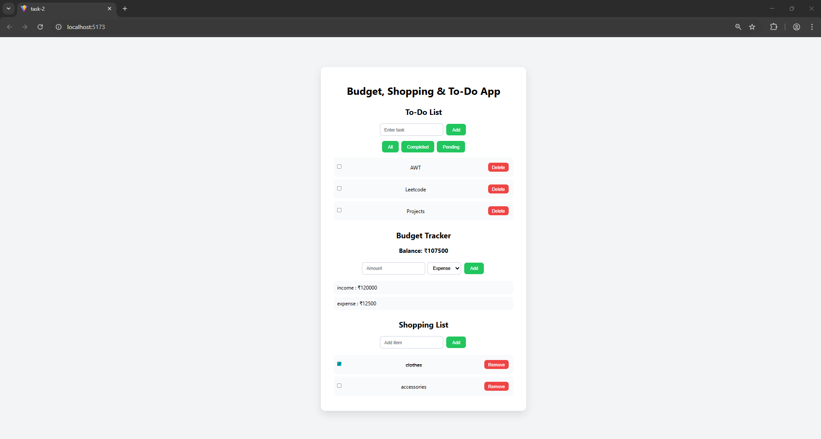

Deliverables:

- Functional To-Do app with the specified features.

Submission Checklist:
  - Source code with appropriate comments.
  - Screenshot of the application in the browser.

  - Explanation of the use of useState and useEffect.

Expected Learning Outcomes:

By the end of this practical, students will be able to:

- Use useState to manage application state effectively.
- Use useEffect to handle side effects in React components.
- Build interactive applications using React Hooks.
- Extend and customize React components for different use cases.

